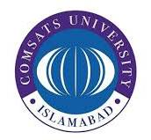
29/11/25

ASSIGNMENT 3

Ideology and Constitution of Pakistan

Secular vs Theocratic State
A Comprehensive Analysis of the Secular vs. Theocratic Dilemma in Pakistan’s Legal Framework: From 1947 to the Present

Ahmed Ali Khan
Athar Abbas
Moaz Nadeem
Naeem Akbar
Mukaram Nadeem
Talha Ahmad

SP25 – BSE – 010
SP25 – BSE – 082
SP25 – BSE – 091
SP25 - BSE – 094
SP25 - BSE – 106
SP25 – BSE - 127

Comsats University Lahore

Submitted To : Saima Akhtar
Contents
1. Introduction 4
2. Historical Context: The Roots of the Dilemma (1947–1949) 4
2.1 The Modernist Vision 5
2.2 Public Narrative of Islam 5
3. Findings and Discussion 5
3.1 The First "Handling": The Objectives Resolution (1949) 5
3.2 The 1973 Constitution: 6
3.3 The Turning Point: General Zia-ul-Haq and Article 2A 7
3.4 The Hudood Ordinances and Social Engineering 8
4. Analysis of Effects 8
4.1 Legal Confusion and Uncertainty 8
4.3 Sectarian Polarization 9
4.4 Alienation of Minorities 9
5. Conclusion and Recommendations 9
5.1 Conclusion 9
5.2 Proposed Solutions 10
6. A PERSONAL NOTE 11
7. References 11

This report analyzes Pakistan's "Constitutional Identity Crisis"—the unresolved conflict between its founding as a modern democratic state and the pressure to become a theocratic one.

Executive Summary
The study traces this dilemma from the 1949 Objectives Resolution (which introduced "divine sovereignty") to the 1973 Constitution (declaring Islam the state religion) and finally to the 8th Amendment (Article 2A). This amendment was the turning point, transforming religious principles into substantive law and empowering the Federal Shariat Court as a parallel legislature.

The resulting dual legal system has eroded parliamentary sovereignty and fueled sectarianism. The report concludes that resolving this crisis requires reverting Article 2A to a non-binding preamble and adopting a "Madina Welfare State" model focused on social justice rather than punitive enforcement.

The study tr aces this

The study tr aces this

The study tr aces this

1. Introduction
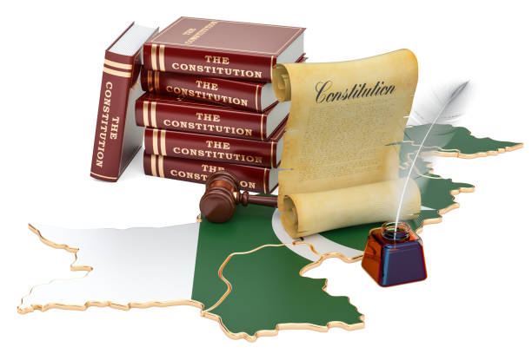
The constitution of Pakistan is not just a record of legal documents : it is a story of ongoing struggle over the country’s identity. Since the partition of the Indian subcontinent in 1947, Pakistan has faced a central, defining question that remains unresolved today: Was this nation meant to be a modern, secular democracy for the Muslims of India or was it created to be a theocratic state based on Islamic law? This report investigates this "Constitutional Identity Crisis" arguing that the tension between these two visions has led to a legal system that is often inconsistent and confusing.
This project focuses on the dilemma of the state's nature and the amendments that shifted Pakistan from a parliamentary democracy towards a religious state. Specifically, we will analyze the "Objectives Resolution of 1949" as the origin of the issue, the "1973 Constitution" as a failed compromise and the "8th Amendment (Article 2A) under General Zia-ul-Haq as the decisive moment that reshaped the country’s legal framework moving it further away from democratic ideals and toward a more theocratic model.
It is critical to understand that this is not just a theoretical debate. The confusion regarding whether our laws are man-made (secular/democratic) or divine (theocratic) affects everything from our banking system to our educational curriculum and the rights of minorities. This report takes a closer look at how this dilemma has been handled over the years and it proposes a solution: moving towards a "Welfare State" model one focused on improving the well-being of all citizens by acting upon principles of religion.

2. Historical Context: The Roots of the Dilemma (1947–1949)
To understand the constitutional amendments that came later we must first understand the conflicting visions present at the birth of Pakistan. The country was founded by the All-India Muslim League led by Muhammad Ali Jinnah. Jinnah and his close associates were modernists at heart. They were constitutional lawyers trained in the British tradition who believed in parliamentary democracy, civil liberties and the rule of law.

2.1 The Modernist Vision
On August 11 1947, Quaid-e-Azam addressed the first constitutional Assembly and presented the strongest evidence regarding secular or modernist arguments. In his speech, Jinnah explicitly discriminated between the business of the state and personal faith of the citizen. He announced that every person residing in the state will be considered as the citizen of Pakistan regardless the discrimination of the religion. This was the clear declaration exposing that the state will be neutral in religious affairs.

2.2 Public Narrative of Islam
However, the public narrative at that time of was Islam and Muslims were united under the banner of Islam. During the Pakistan Movement slogans like "Pakistan ka matlab kya? La ilaha illallah" (What is the meaning of Pakistan? There is no god but Allah) were used to rally support particularly in rural areas. While the leadership might have viewed Pakistan as a political refuge for Muslims, the masses and the religious groups (Ulema or religious scholars) viewed it as a promise for an Islamic Renaissance.
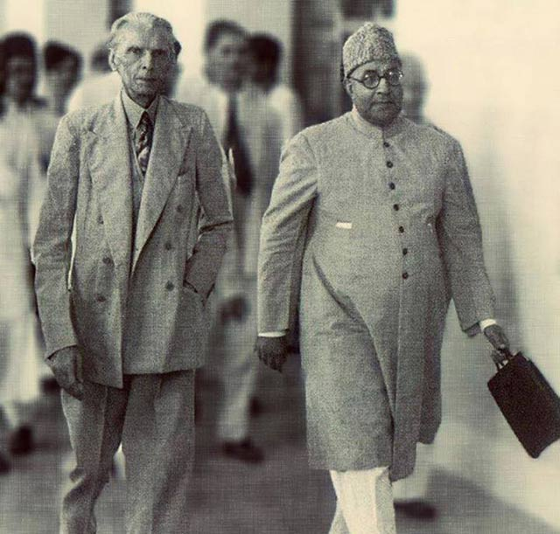
Immediately after independence religious parties like the Jamaat-e-Islami (who had initially opposed the creation of Pakistan) migrated to the new country and launched a fierce campaign. They argued that a country created in the name of Islam could not be governed by "Godless" British laws. They demanded that the Quran and Sunnah be declared the supreme law of the land. This pressure created the first major constitutional crack, one that would continue to shape Pakistan’s legal and political landscape.

3. Findings and Discussion
This section details the specific constitutional events, amendments and dilemmas that transformed Pakistan’s legal landscape.

3.1 The First "Handling": The Objectives Resolution (1949)
The first attempt to resolve the tension between the modernists and the Islamists resulted in the "Objectives Resolution," passed in March 1949 under Prime Minister Liaquat Ali Khan. This document is often seen as the starting point for Pakistan’s journey toward a more theocratic state.
The Resolution began with a powerful statement:
"Sovereignty over the entire universe belongs to Allah Almighty alone and the authority which He has delegated to the State of Pakistan... is a sacred trust."

Analysis of the Dilemma:
In a standard democracy (like the UK or India) sovereignty belongs to the people. The people elect representatives and those representatives make laws. If the people want a law changed, they vote for new representatives. However, by declaring that Sovereignty belongs to Allah, the Objectives Resolution introduced a divine veto. If Sovereignty belongs to God then human parliamentarians cannot pass a law that contradicts God’s law.
One problem is interpretation. Men interpret God’s word. This opens the possibility that whoever has the power to interpret religious law can override the decisions of elected politicians. In other words it starts to give religious authorities more control over the state than the people’s representatives.
During the debate in 1949, non-Muslim members of the assembly such as Sris Chandra Chattopadhyaya warned that this resolution would essentially make non-Muslims second-class citizens and mix religion with politics in a dangerous way. But their warnings were ignored and the Resolution was passed. At that point, it wasn’t yet a binding law, but more of an introductory statement. Still, it planted the seeds of a religious influence on the constitution that would grow over time.

3.2 The 1973 Constitution:
After the failed constitutions of 1956 and 1962 and the tragic separation of East Pakistan in 1971, the nation needed a fresh start. Zulfikar Ali Bhutto, who was a socialist with a secular lifestyle but a populist leader, took charge and pushed for the 1973 Constitution.
This new constitution was meant to be a compromise between the modernist and Islamist forces all while trying to bring the country together after the loss of East Pakistan.

Key Religious Provisions in 1973:
- Article 1: Pakistan was named the "Islamic Republic of Pakistan."
- Article 2: For the first time, Islam was declared the State Religion.
- Article 31: It became a fundamental policy of the state to help Muslims live their lives according to the teachings of Islam.
- Article 227: This was the crucial "Islamic clause." It stated that no law could be passed if it contradicted the teachings of Islam as laid down in the Quran and Sunnah.
- The Second Amendment (1974):
The tension between religion and governance escalated further in 1974 when the Parliament passed the Second Amendment, declaring Ahmadis as non-Muslims. This was a watershed moment. For the first time, the State took upon itself the theological right to define who is and who is not a Muslim. This shift turned the Constitution from a political and legal framework to a document with theological authority.
Despite these provisions, the 1973 Constitution remained largely democratic in function. The "Islamic" clauses were mostly guiding principles. The courts could not strike down a law just because a citizen felt it was un-Islamic. That power still rested with the Parliament.

3.3 The Turning Point: General Zia-ul-Haq and Article 2A
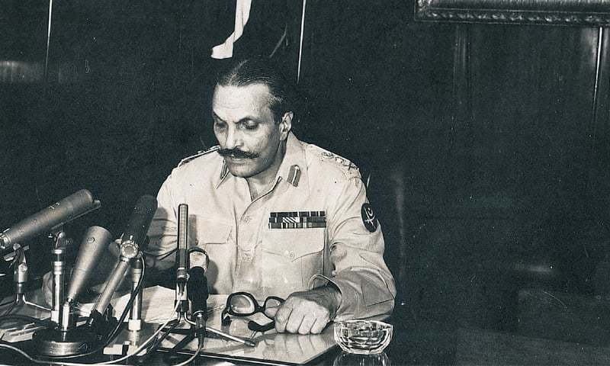
The most significant "Amendment" regarding this topic and the one that caused the most lasting damage to the secular-democratic balance occurred under the military dictatorship of General Zia-ul-Haq (1977–1988).
Zia lacked a popular vote, so he sought legitimacy through religion. His goal was the total "Islamization" of Pakistan’s legal structure. He argued that the 1973 Constitution was contradictory because it claimed to be Islamic but didn't give Sharia courts the power to overrule the Parliament.
The Revival of Constitution Order (RCO) 1985:
Zia introduced the 8th Amendment, which inserted Article 2A into the Constitution. This article had a profound effect on Pakistan’s legal landscape.
The Impact of Article 2A:
Article 2A stated that the principles set out in the Objectives Resolution are hereby made a substantive part of the Constitution.
This legal terminology had explosive consequences. Before 1985, the Objectives Resolution was more of a vision or guiding statement with no legal teeth. By making it "substantive," Zia turned it into a powerful constitutional governing law.
Suddenly, the High Courts were flooded with cases. Lawyers began arguing that everyday laws such as banking interest, inheritance rules and land reforms, should be considered "invalid" because they went against Article 2A, which says sovereignty belongs to Allah.
This created a wave of legal challenges with people questioning whether even the most basic laws could stand if they didn’t align with Islamic teachings. It was a shift that turned everyday legal issues into a battleground for religious interpretation.
Establishment of the Federal Shariat Court:
To make this shift official, Zia established the Federal Shariat Court. This court was given the unique power to examine any law on the books and decide if it was "repugnant" to Islam. If the Sharia Court declared a law un-Islamic, the government had to change it. This effectively created parallel legislature.

3.4 The Hudood Ordinances and Social Engineering
Along with this constitutional overhaul, the state started shifting from being a neutral authority to acting as a moral enforcer.
In 1979, the Hudood Ordinances were introduced, which brought strict physical punishments for crimes like theft, adultery and drinking alcohol.
This period marked the height of the "Theocratic" experiment in Pakistan, where the constitution was used not just to govern, but to enforce a specific, rigid interpretation of morality that affected the lives of millions.
The problem with Hudood Ordinances and other amendments of that era was that applying Islamic hudood and some other Islamic rules without implementing the Islamic System was not going to work. Islam has its own Political and Economic System.

4. Analysis of Effects
Pakistan has had significant, multigenerational impacts from the way the constitutional question has been handled through forced Islamization and amendments like Article 2A.

4.1 Legal Confusion and Uncertainty
The most direct consequence is the development of a "Dual Legal System." Sharia Law is placed on British Common Law (Civil/Criminal Procedure Codes) in Pakistan. This leads to unforeseen results.
For instance, the Federal Shariat Court and the Supreme Court have been debating "Riba" (interest) for many years. Because interest is the foundation of the current global economy, the Supreme Court issues stay orders despite the Sharia Court’s declaration that interest is un-Islamic.

4.2 Erosion of Parliamentary Sovereignty
The Parliament is no longer supreme due to Article 2A. The will of the people is final in a functioning democracy. In Pakistan, the judiciary's interpretation of religion takes precedence above the will of the people. This has hindered the development of democratic norms and political parties. For fear of being deemed "un-Islamic" by the courts or religious pressure organizations, lawmakers are frequently reluctant to discuss delicate subjects (such as the Blasphemy Law).

4.3 Sectarian Polarization
Which Islam?" is the first thing that comes to mind when the Constitution states that the state is "Islamic."
Shias and Sunnis (Barelvis, Deobandis, Ahle Hadith) reside in Pakistan. Sharia is interpreted differently by these groups. The constitution unintentionally stoked sectarian strife by attempting to impose one interpretation of Islamic law through the official apparatus. Extremist organizations felt it was their responsibility to impose their interpretation of the "ideology of Pakistan," frequently through violence, because of the state's participation in defining religious correctness.
For example , Shias were against the Ushar and Zakat System of Zia ul Haq , as system of zakat was viewed differently by Shia scholars. It resulted in sectarian riots and extreme violence in 1980’s.

4.4 Alienation of Minorities
The original goal of the "Two-Nation Theory" was to safeguard India's Muslim minority. Ironically, non-Muslim minorities in Pakistan namely Christians, Hindus and Sikh are now at risk due to religious changes. The introduction of separate electorates (during Zia’s time, later removed by Musharraf) and the social environment created by these laws have led to a "brain drain," where talented individuals from minority communities leave the country.

5. Conclusion and Recommendations

5.1 Conclusion
The constitutional history of Pakistan forms a perfect example of what occurs when two diametrically opposite systems, namely theocracy and democracy, are forcibly made to integrate into one state. What started as a demand for a homeland where Muslims could be freed from economic persecution a demand articulated by Jinnah changed shape and evolved into a demand for a theological state where the clergy should have the final veto , a demand embodied by Zia.
The introduction of Article 2A and the Federal Shariat Court did not make the people more pious or the government more honest. In its wake, it produced a confusing legal hybrid that hampered economic progress, fueled sectarian violence and marginalized minorities. The "dilemma" was handled not by debate and consensus but by military dictators using religion to prolong their rule.

5.2 Proposed Solutions
We propose the following solutions to resolve this dilemma and steer Pakistan towards stability.

Recommendation 1: The "Madina Welfare State" (Riyasat-e-Madina) Model
The present definition of "Islamic State" in Pakistan is obsessed with punitive laws-whipping, hanging, banning, which is fundamentally flawed. We suggest that the ideology be redesigned to conform to the "Charter of Madina."
The Prophet’s state in Madina was characterized by:
- Rule of Law: No one was above the law.
- Social Justice: The primary state responsibility was the welfare of the poor through Bait-ul-Mal.
- Pluralism: the Medina Charter was a social contract in which Jews and Pagans were accorded equal political rights and autonomy.
Action Plan: The Parliament should shift the focus of the "Council of Islamic Ideology" away from moral policing to "Economic Islam" which should be about creating mechanisms for Zakat that will assist the poor, ensure women receive their rightful inheritances and root out corruption.
Recommendation 2: Restoring the Preamble (Revisiting Article 2A)
The Objectives Resolution is a beautiful piece of prose, but it is too vague to be a law.
Action Plan: A constitutional amendment should be carried out to restore the Objectives Resolution to its original status as a Preamble. It should be a guiding light for legislature but not "substantive law." It would restore the sovereignty of the elected Parliament and eliminate the dual court system confusion. The courts should interpret the law, not theology.

Recommendation 3: Judicial Unity
Action Plan: This means that the Federal Shariat Court should be merged into the Supreme Court and a single, integrated judicial hierarchy institute. The Islamic scholars can be called as amicus curiae to give expert opinions but not act as judges unless they are trained in modern law, the purpose of this being to ensure the application of Islamic principles.
Recommendation 4: Inclusive Education
Action Plan: The "Ideology of Pakistan" subject in universities should be critically rather than dogmatically taught. Students must be made to read Jinnah's August 11 speech along with the Objectives Resolution for an understanding of the nuance. We need to teach that a Secular State-neutral state-does not mean an Atheist State. A state could be neutral while its people are religious. This will establish a very important difference required for the future of Pakistan.

6. A PERSONAL NOTE
As a personal note , I would like to add an interview of student , conducted in 1970’s.
“You know what Mr. Bhutto says? He says our religion is Islam, our economics is socialism, and our political system is democracy. Now, I suppose any sensible person could see that all these three things could not co-exist. If you want to have democracy like the secular democracy in Europe, you can have that.
If you want to have the proletarian dictatorship as in China and Russia, you could have socialism. And if you want to have Islam, you must have Islam in total because Islam has its own economic system, its own political system and its own religious traditions. And I suppose that if we are diverted from Islam in total, then ultimately Pakistan may have to join India.”

7. References
- Constitutional Documents:
  - The Constitution of the Islamic Republic of Pakistan, 1973. (Government of Pakistan).
  - The Objectives Resolution, 1949. (Constituent Assembly of Pakistan).
  - The Revival of the Constitution Order (RCO), 1985. (President’s Order No. 14 of 1985).
- Books and Academic Texts:
  - Khan, Hamid. (2017). Constitutional and Political History of Pakistan. Oxford University Press. (This text provided the core chronological data regarding the amendments).
  - Jalal, Ayesha. (1995). Democracy and Authoritarianism in South Asia. Cambridge University Press. (Used for analysis of the bureaucratic-military nexus).
  - Ziring, Lawrence. (1997). Pakistan in the Twentieth Century: A Political History. Oxford University Press.
  - Mahmood, Safdar. (2000). Pakistan: Political Roots and Development. Vanguard Books.
- Case Law:
  - Asma Jilani v. The Government of the Punjab (PLD 1972 SC 139). (Critique of martial law and the doctrine of necessity).
  - Hakim Khan v. Government of Pakistan (PLD 1992 SC 595). (Supreme Court ruling on the scope of Article 2A).
  - Zaheer-ud-din v. The State (1993 SCMR 1718). (Analysis of minority rights and religious freedom).
- Journal Articles:
  - Kennedy, Charles H. (1990). "Islamization and Legal Reform in Pakistan, 1979-1989". Pacific Affairs.
  - Lau, Martin. (2005). "The Role of Islam in the Legal System of Pakistan". Yearbook of Islamic and Middle Eastern

